Ethiopian National Disability Action Network (ENDAN)

Proceedings of
A Validation Workshop on the Preliminary Findings of an AssessmentConducted on Disability Sensitivity/Inclusiveness of Ethiopian Government Policies and Laws with Respect to Employment/Labor Market
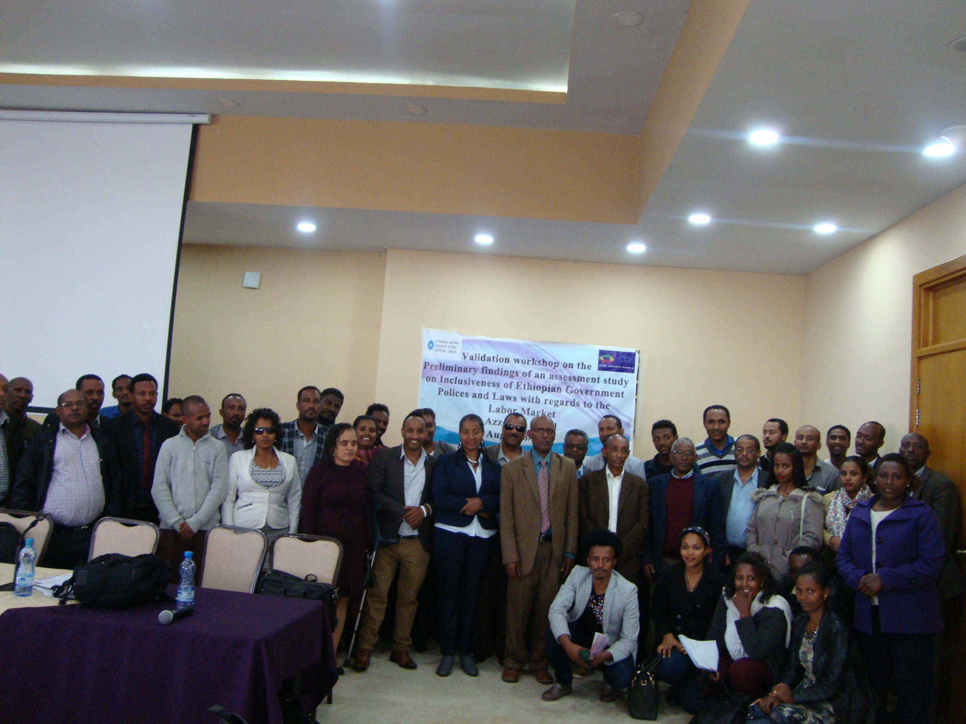

Supported with a Grant and Technical Support of European Union Civil Society Fund
(EU CSF) II

August, 2017

Opening Session
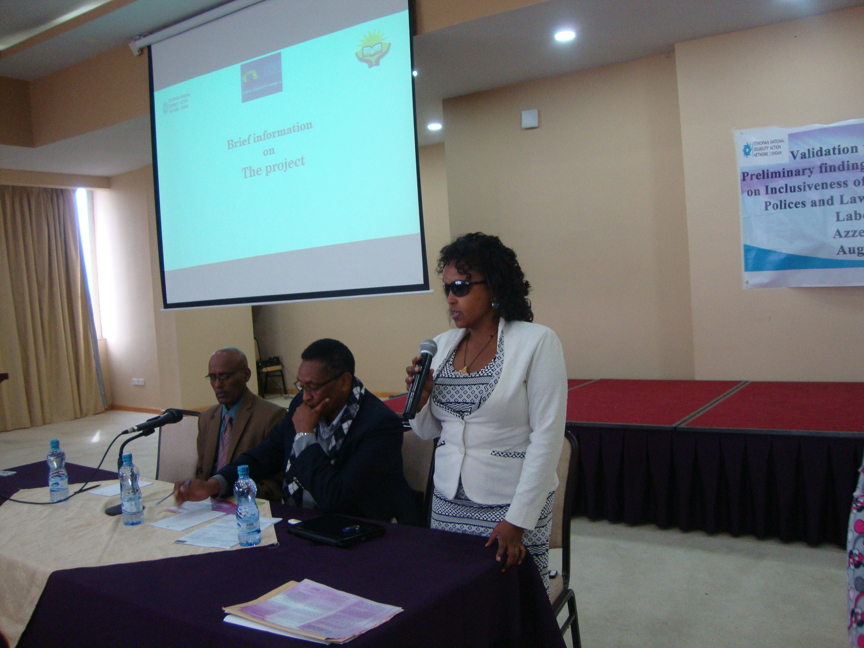
Introductory remark was made by Miss Hanna Bekele, General Manager of ENDAN. She explained that the workshop was an integral part of a multi-stakeholder and multi-component project entitled “Promoting Disability Inclusive Development Practice in Key Socio-Economic Sectors”, supported by a grant of EU-CSF II. In her remark, she said that the conduct of an assessment study entitled “The Disability Sensitivity/Inclusiveness of Ethiopian Government Laws and Policies with Particular Reference to the Employment/Labor Market” is the major component of the Action. Enriching the preliminary findings of the Assessment with inputs of relevant stakeholders is also another component of the project and is the major agenda of the day. Following this brief explanation, she called upon Ato Facil Ayele, the Board Chair of Ethiopian National Disability Action Network to deliver the welcoming speech.
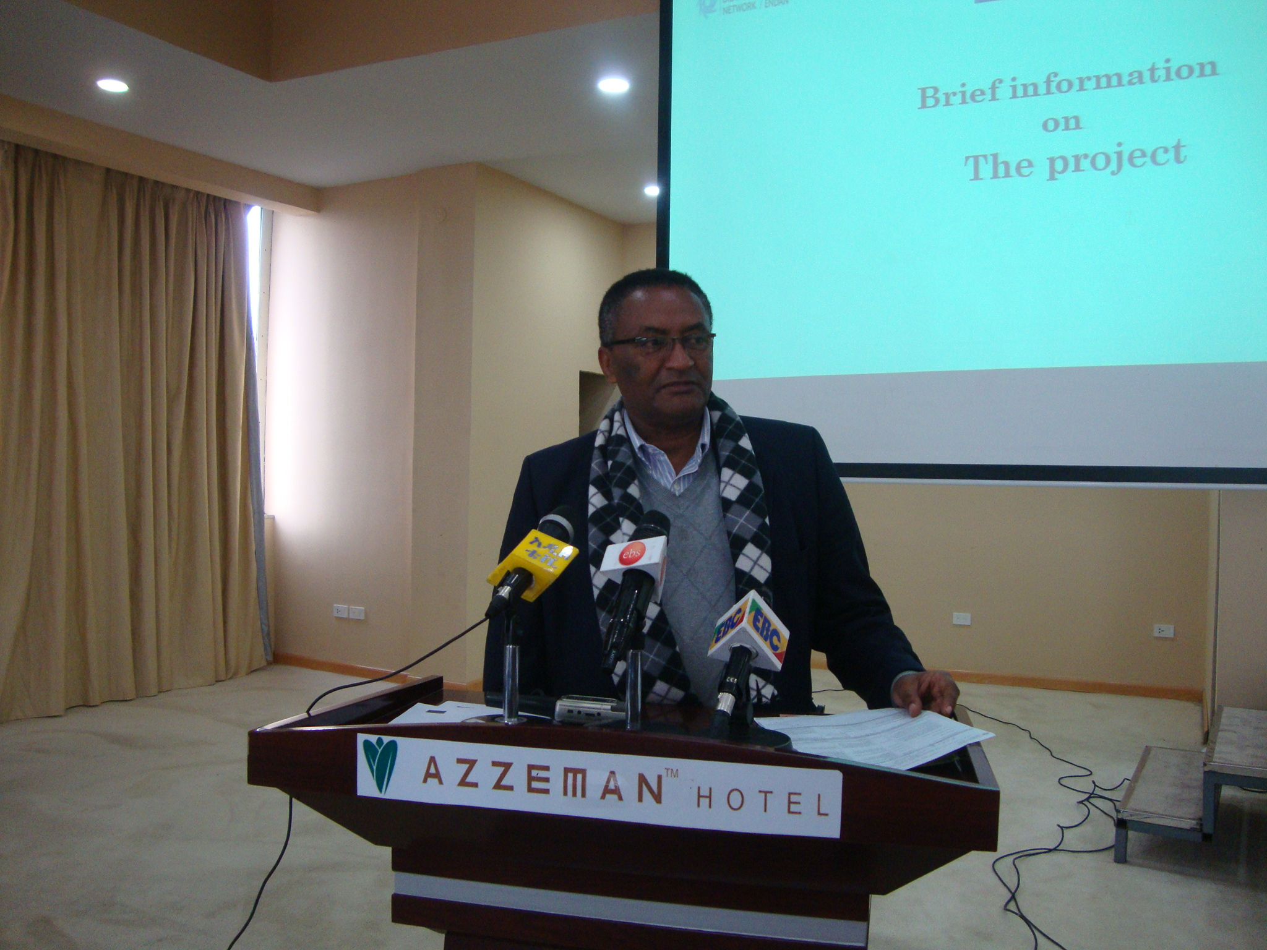
Ato Facil, in his remark said that ENDAN is a network organization that was established by the member organizations working on disability. Since its formation, the Network has served as a common platform for members. He notified to the participants that currently ENDAN in collaboration with NOVIB is conducting three assessment reports in the area of education, livelihood /employment and accessibility. He confirmed to the participants that the validation workshop focuses on the preliminary assessment made on disability inclusive employment and called upon their active participation to enrich the assessment. He finally invited Ato Abebe Gebre-Medhin, the representative of State Minister of the Social Affairs, Ministry of Labour and Social Affairs to deliver an opening speech.
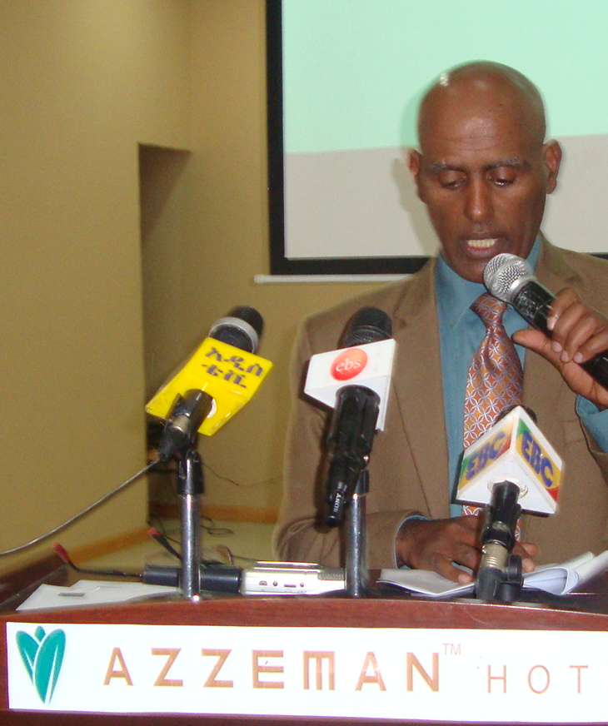
Ato Abebe G/Medhin, after expressing his happiness to deliver an Opening Remark in such validation workshop mentioned the measures undertaken by the government to ensure equal opportunity and participation of persons with disabilities. Among the measures mentioned, issuance of policies and laws, organizing executive organs and coordinating stakeholders to fight discrimination were the prominent ones. He also mentioned the important legislations promoting employment of PWDs and further noted that they are not yet fully materialized despite the increasing efforts by different actors. He also stressed the importance of increasing the level of awareness of the executives, implementers and persons with disabilities on legislations issued to ensure the socio-economic well being of persons with disabilities. The need for multi-stakeholder integration is mentioned as a strategy. He finally noted that the assessment that is being conducted by ENDAN is expected to identify the legislative gaps on Employment of PWDs, and hence called upon the participants to pursue the workshop in lieu of identifying the strength and gaps in the legislatives which can further be taken as input for future action by the ministry and relevant actors.
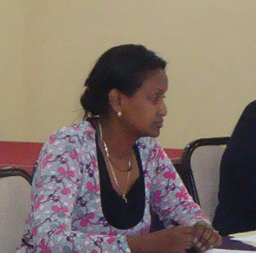
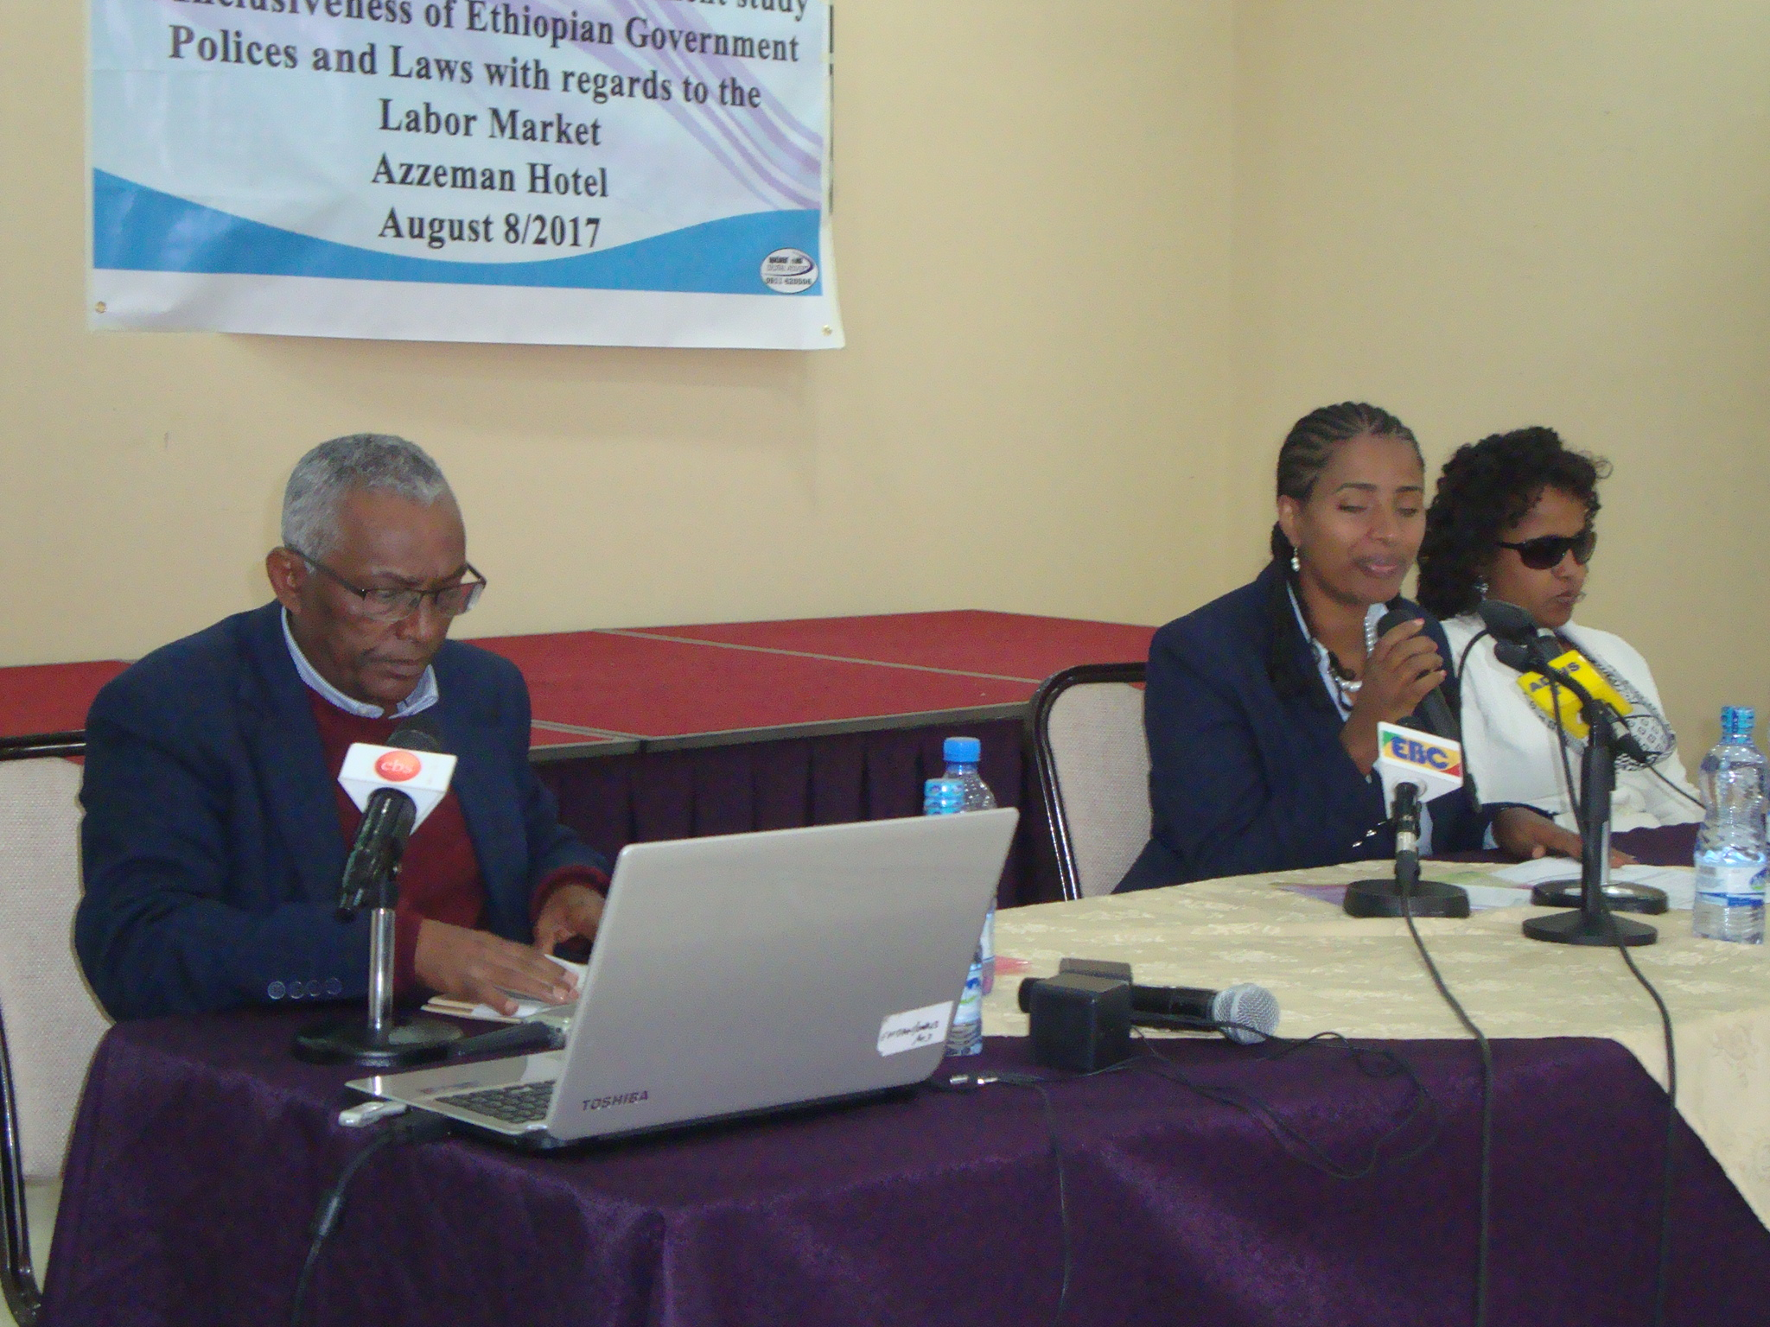
Following the opening speech, Mrs. Hanna Nebiye, EUCSFII Project officer of ENDAN made a presentation about general overview of the collaborative Action Project, its objectives along with the respective activities. She further clarified that the three assessments that are being conducted in the area of access to education, employment and physical infrastructure are aimed to increase the participation of PWDs in the development programs and services. She alluded that the outcome of the assessments after enriching these with relevant stakeholders will be used to draw the attention of the key government organs thereby promoting disability inclusive development.
Mrs. Yetnebersh Negussie, moderator of the workshop, has invited the participants to introduce each other. A total of 62 participants attended the workshop. Among these, 14 are females and 8 are persons with disabilities. From the participants that attended the workshop, representatives of government executives, non government organizations, DPOs and the media were found.
Presentations
A series of 3 presentations were made:
- “Disability Inclusion in Ethiopia with focus on Inclusive Employment:-facts, Policies/Laws, Challenges and Recommendations” by Ato Fantahun Melese, National Project Coordinator on Disability, ILO. The presentation was prepared based on document review conducted by ENDAN and enriched by Ato Fantahun for the purpose. The summary of the presentations is depicted as follows.
- Concept and facts about disability
In the presentation, Disability is defined as a combination of Impairment and the legal, attitudinal and physical barriers. Therefore, impairment will be stand alone in a barrier free environment which is less problematic for PWDs. Facts on disability were also mentioned during the presentation that include the followings;
- 15% of the total population of the world is PWDs (World Health Organization (WHO), 2011) whereas CSA estimated the percentage of PWDs to be 1.17% persons.
- Due to the existing attitudinal problem, PWDs didn’t have access to job and even those employed are in low prospect jobs.
- It is also indicated that Ethiopian losses 5% of its GDP by excluding PWDs from the development aspects. (The price of Exclusion)

- Inclusive development and inclusive employment
Ato Fantahun indicated that inclusion is a process and challenges the curtain on exclusive structures, practice, norms etc. Inclusion is described as a means of creating opportunity. The road to disability inclusive development has two tracks. The first is including the issue of disability in all economic sectors/disability mainstreaming and the second is following a disability tailored approach.
- Laws and policies on disability inclusion in Ethiopia
In this section of the presentation major national policies and legal frameworks on the inclusion of persons with disabilities in the labor market/employment sector had been assessed. The ratification of UN-CRPD by Ethiopian government in 2010 is considered as a major step towards creating an inclusive society. Proclamation 568/2007 on the right to employment of PWDs was drafted based on the social model of disability and is the vital disability-focused legal provision that ensures the inclusion of PWDs in the labor/employment market.
Article41 (5) of the Constitution, Article 29 of labor law (Proc No 377), Article13 (1) of Proc515/2007 were also mentioned as national laws that hold provisions promoting access to employment of PWDs. It was also noted that proclamation No. 916/2015 has made the issue of disability the concern of all public enterprises. The existence of such legal provisions is considered as an opportunity for PWDs.

- Gaps observed in the existing policy and legal frameworks
The major drawbacks identified by the assessment include:
- Lack of monitoring mechanism
- Lack of awareness
- Weak institutional arrangement
- Lack of performance management
- Absence of penalty on non-compliance
- Absence of synergy and harmonization

Recommendations based on the findings
Sets of recommendations were forwarded for Government Ministries, Agencies, and Sector Bureaus/Offices, Associations of Persons with Disabilities/DPOs, and Networks of DPOs and even for persons with Disabilities themselves. The recommendations given to the executive organs are listed as follows.
- Harmonize and update regional proclamations, standards, and regulations with Federal laws.
- Build the capacity of relevant actors on the conventions, polices and laws.
- Monitor and ensure the effective implementation of the legal frameworks on disability inclusive employment.
- Establish department/unit staffed with adequate personnel to support and follow the implementation of legal frameworks on disability inclusion in the employment sector.
- Engage in awareness creation on disability focused legislations.
- Conduct targeted awareness raising and sensitization activities on employers, (mainly the private sector) and trade unions.
- Assign focal persons in both private and public sectors to effectively monitor and evaluate the implementation of disability inclusive legislations.
- Capture national and regional data on employment of persons with disabilities (gender and disability- types disaggregated).
- Allocate resources for disability employment support services

Presentation two:- “The Attitude of Public Enterprise Employers towards Women with Disability: The case of selected enterprises” by Meslu Fikre, Senior expert, Social sector good governance, research and implementation, monitoring and support directorate, Ministry of Public Service Human Resource Development.

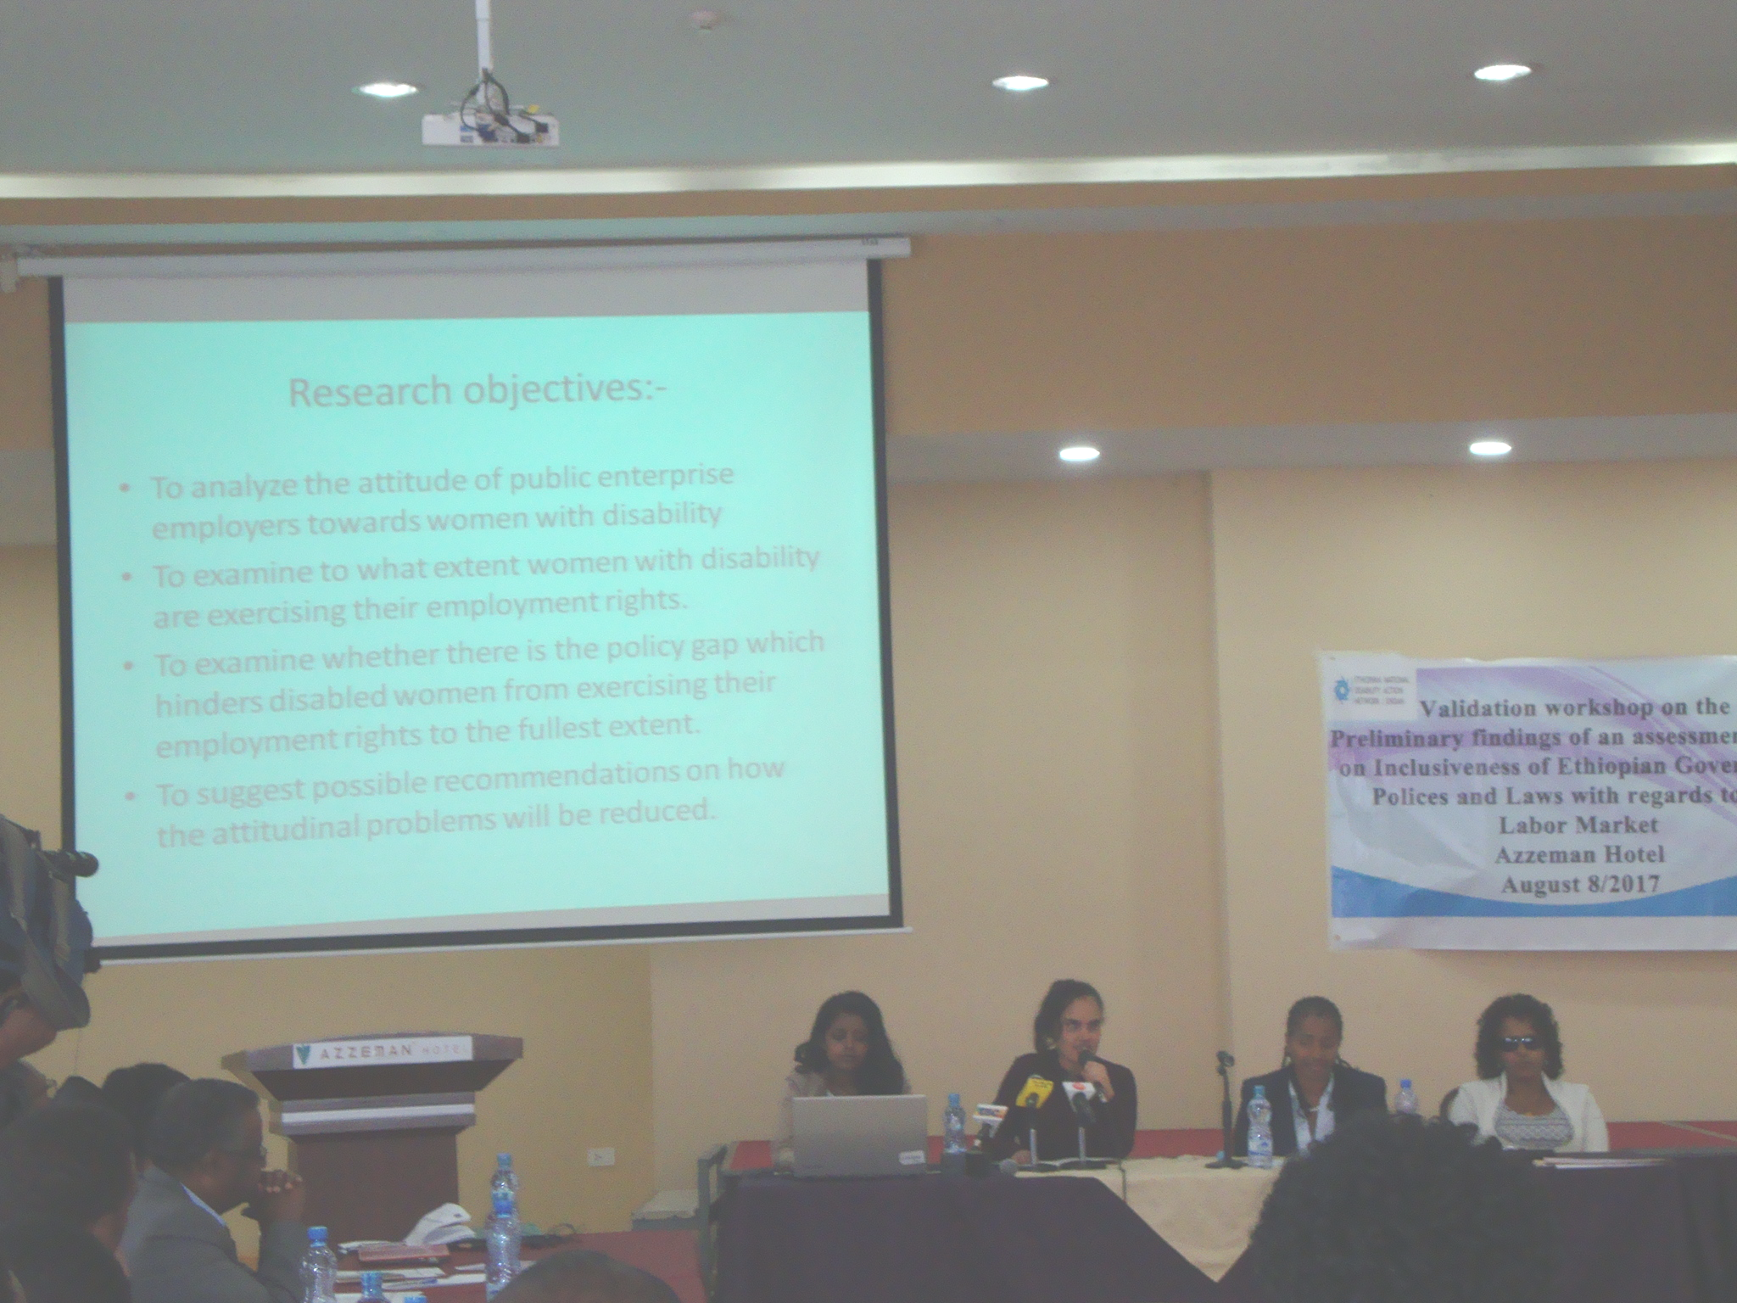
Meselu introduced major contents of her presentation which include: Objectives of the study, methodology, findings and recommendations. The major findings of the research presented during the workshop that hindered employment of women with disability in particular and persons with disabilities in general include:
- Low level of education,
- Lack of information about the vacancy announcement and about the legal matters;
- Negative attitude of the employers, unwillingness to employ women with disability due to attitude
      - Fear of additional cost of reasonable accommodation.
      - Unfavorable working conditions
      - Prevalence of legal gaps such as lack of affirmative action in labor proclamations, lack of incentives for public enterprise employers in proclamation no. 568/2008.

The recommendations made by Meselu are presented as follows:
1. Awareness creation programs aimed at changing the mind set of public enterprise employers should be conducted through media, discussion forums, and public awareness raising campaigns at national level.
2. The legal gaps should be minimized through amending the laws that hinder disabled women from fully exercising their employment rights.
3. Public enterprises should mainstream the issue of disability in to their day to day activities through incorporation of the rights of disabled women in their human resource documents and creating conducive working environment for disabled women.
4. There should be a follow up strategy to enforce the employment rights of disabled women. A proportional disciplinary measure should be taken as a consequence of discriminatory actions.
5. Government should support the disability associations and build their capacity to stand for the rights of their members. The government should also make them participate in policy formulation and implementation son the issues related with the rights of persons with disability.
6. A series of research studies in relation to disability should be carried out by the concerned bodies such as governments, think tanks and other interest groups and statistics on the number of persons with disability should be organized by the pertinent body.
Presentation Three: - Inclusive skills training and employment programs of ECDD by Melaku ,program manager at ECDD.
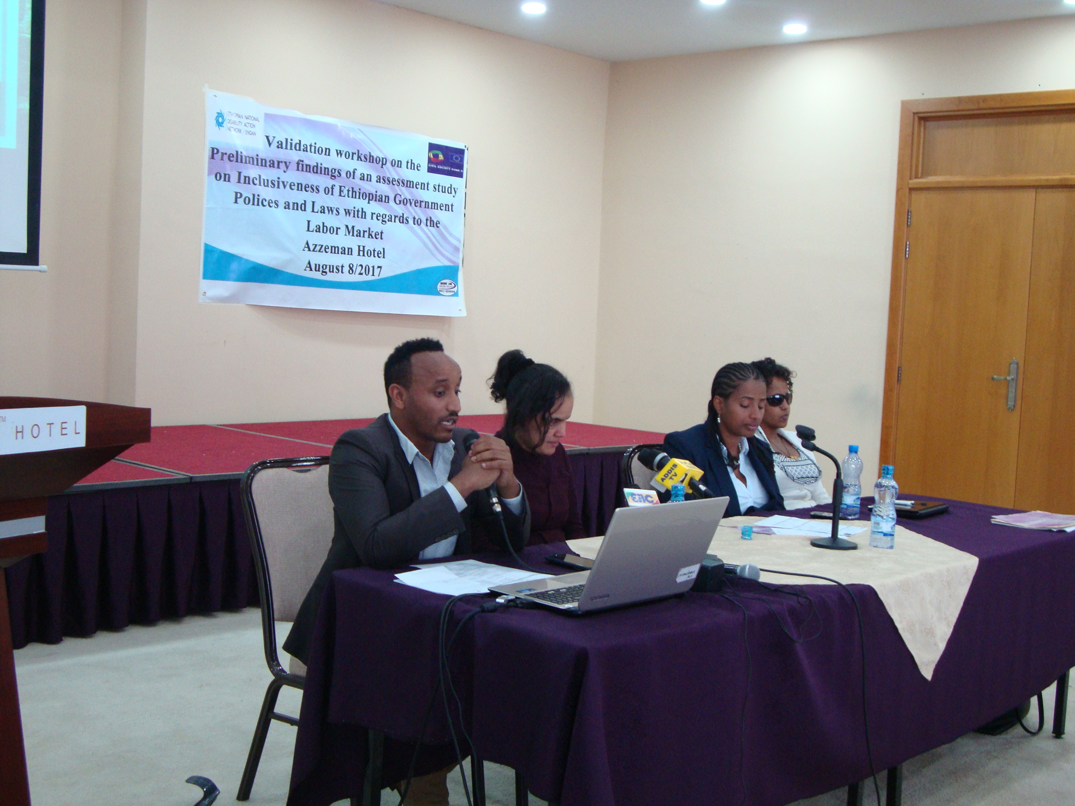
This presentation was made to show the experience of ECDD in inclusive skills training and employment of persons with disabilities. In this regard, Ato Melaku has explained the experience in three projects of ECDD (ABILIS, ISTEP& Employable). Under the ABILIS project ECDD grants 2,500 to 10,000 Euros in fast, mid and regular terms after their proposals were screened by internal review board. Through this process 120 groups have benefited.
The project facilitated vocational skills training opportunity for 302 (M=117 & F=185) youths and adults with disabilities in various types of vocational training that is different from the stereotype. The vocational training includes food preparation, Hair Dressing, Leather Goods Production, Construction, Gypsum works, Auto Mechanic, Metal works; wood working, Cobblestone work, Music, Laundry and Tailoring. An internship program facilitated for 168 youths and adults (F= 111 & M= 57) were placed in an internship program in different host organizations. During this time ECDD covered the transportation and related cost. Through this program employers were given the opportunity to understand the potentials of persons with disabilities.
Through the Employable program, accessibility audit and modifications, accessibility monitoring of TVETs, training of TVET staffs and teachers and purchase of assistive devices were made to promote the inclusion of persons with disabilities in TVETs. In this regard, the experiences of other countries on how to train persons with different types of disabilities were taken and shared with the TVET organizations.
Discussion Session
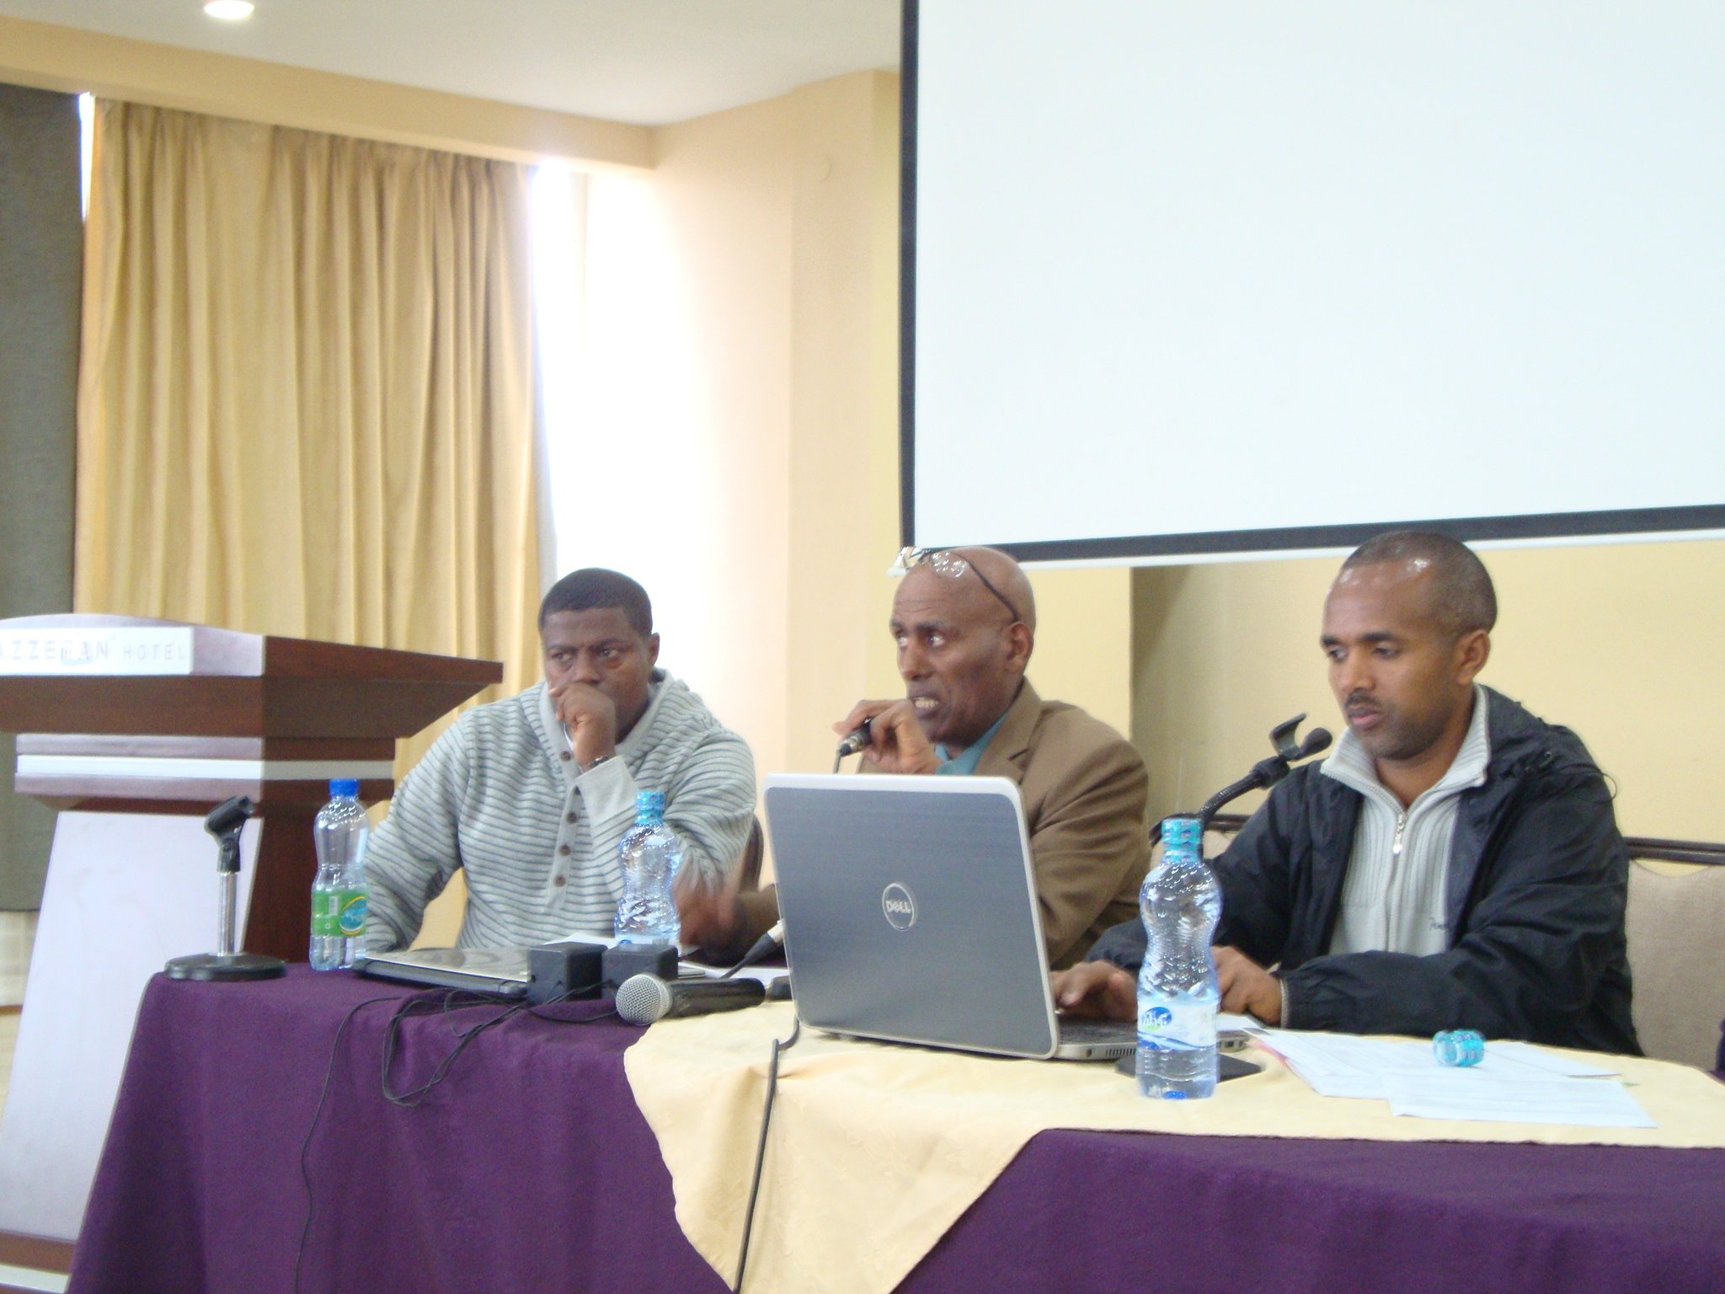
Lead discussants Ato Abebe G/Medhin from MOLSA, Ato Yidenekachew Hailu from BOLSA and Ato Sirka Mamo, from FESMMIDA made their reflections on the three presentations made; Ato Abebe G/Medhin has expressed his appreciation to the organizer for bringing the agenda for discussion. He confirmed the findings of the presentations as valid and mentioned that the identified gaps in implementation of UNCRPD are related to capacity limitation and lack of awareness. He affirmed that implementation gaps are more a problem than the gaps in laws and policy and questioned the need for “Disability Act. He further described that his office is working to fill the implementation gap.
He affirmed the usefulness of the recommendations made to incorporate the inspection of accessibility of working environment as part of the labor inspection assignment under MOLSA. He informed ENDAN that, labor law i.e.Proc.No.377 is under revision and hence the appropriate recommendations made can be incorporated.
Ato Yidnekachew Hailu from AA BOLSA mentioned that the presentations are useful to identify the gaps on the existing laws and legal provisions in view of inclusion of persons with disabilities in the employment/labor market. According to him, lack of awareness on the existence of the legal provisions by PWDs contributes to the poor enforcement of the laws.
Awareness creation at societal level on the issue of disabilities regarding the existing laws, directives, regulations etc is also vital. ECDD’s experience of ‘knocking at the doors’ of employers for providing employment opportunities for PWDs and increasing their level of awareness are the new lessons that could be duplicated.
Ato Sirak has mentioned that it is a timely agenda and coincides with the annual plan preparation the event has given us important inputs. He has also indicated that, to mitigate the employment problem of PWDs it is important to create entrepreneurs /employers which is being done by FESMMIDA. He has also shared the organizers important information regarding the youth program initiated for the next 5 years. The program intended to create employment opportunity for youth this can be tapped by youth with disabilities as well.
Some of the questions raised by participants include:
- What is the cause for the discrepancy between the number of PWDs in Ethiopia as reported by WHO (17.6%) of the population and that released by CSA (1.76%)?
- Recruitment is a process which requires approval of all involved parties and in the earlier times, Ethiopia follows quota based recruitment procedure which means out of the total number of employees some percentage have to be PWDs but this days it become merit based, which is one is more applicable and advantageous to our country situation
- Among the legal provisions, VAT proclamation states that if 60% of the employees of an organization are PWDS, the organization is not obliged to pay VAT, is it feasible/applicable? Can we take this as an opportunity for PWDs?
- The provision for PWDs to claim their right if denied access to job by Proclamation 568 is restricted by proclamation number 621/2009 since the later didn’t allow local DPOs to work on right/advocacy issue, are they not contradicting?
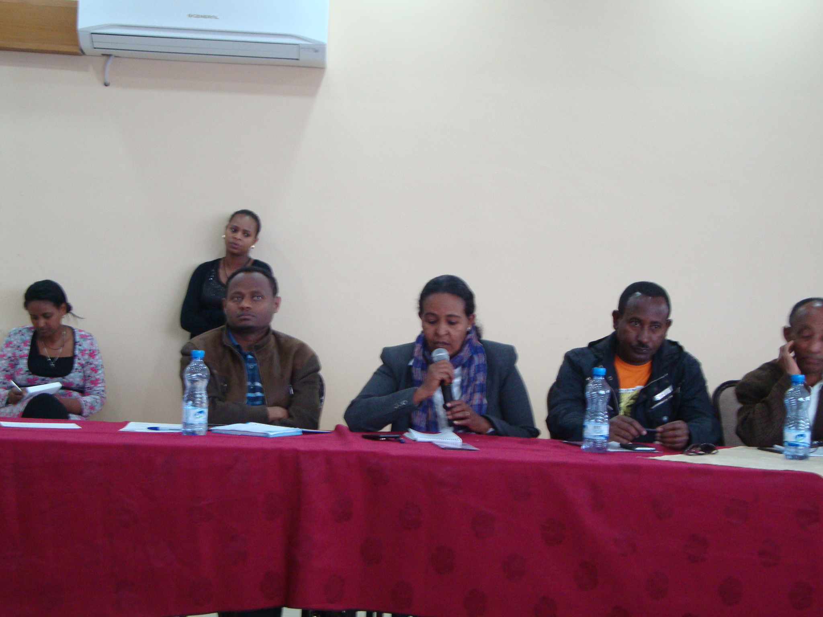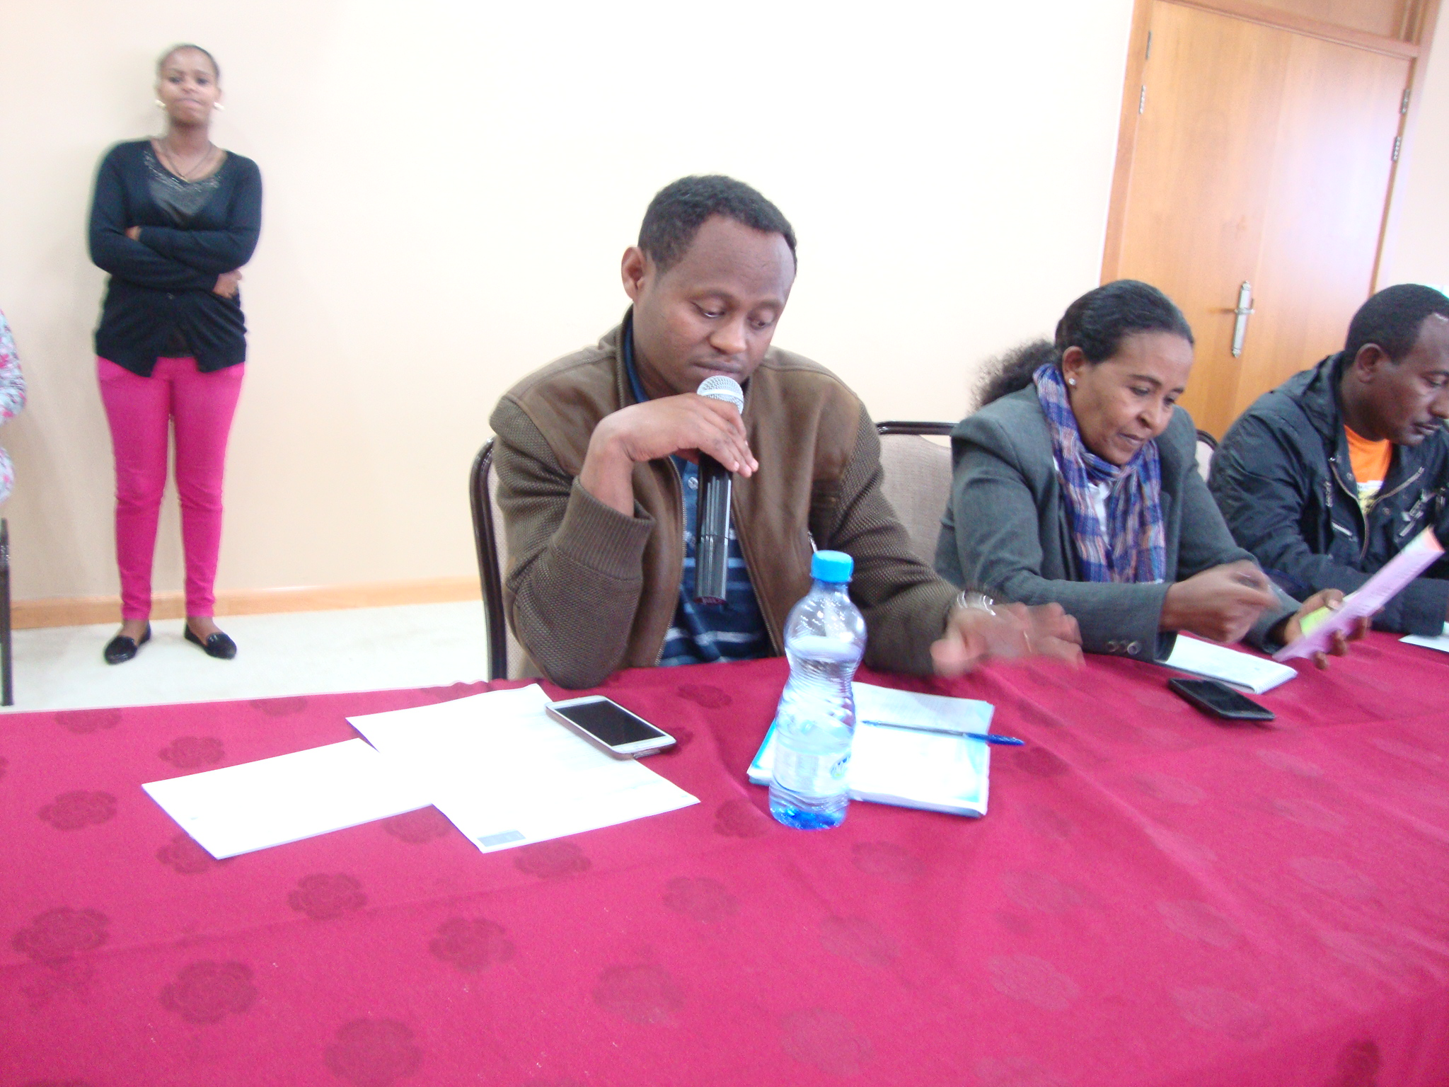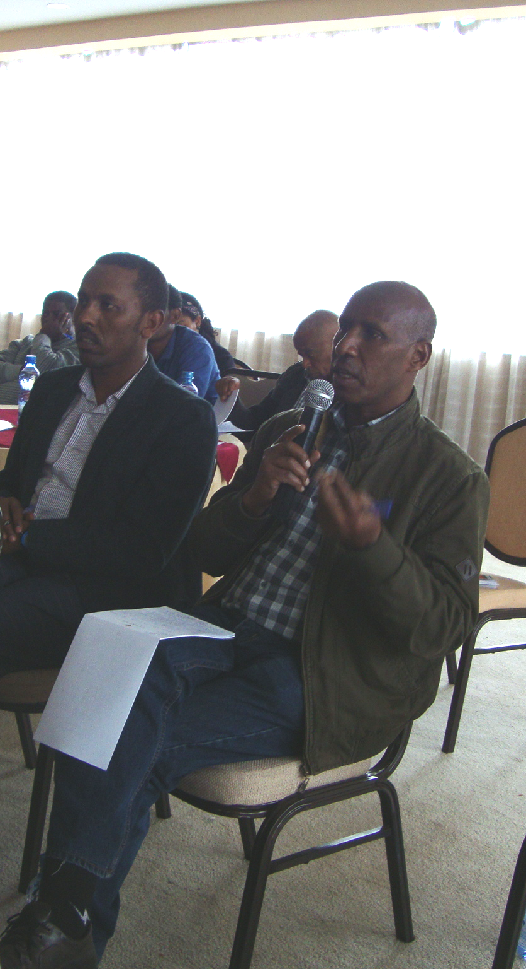
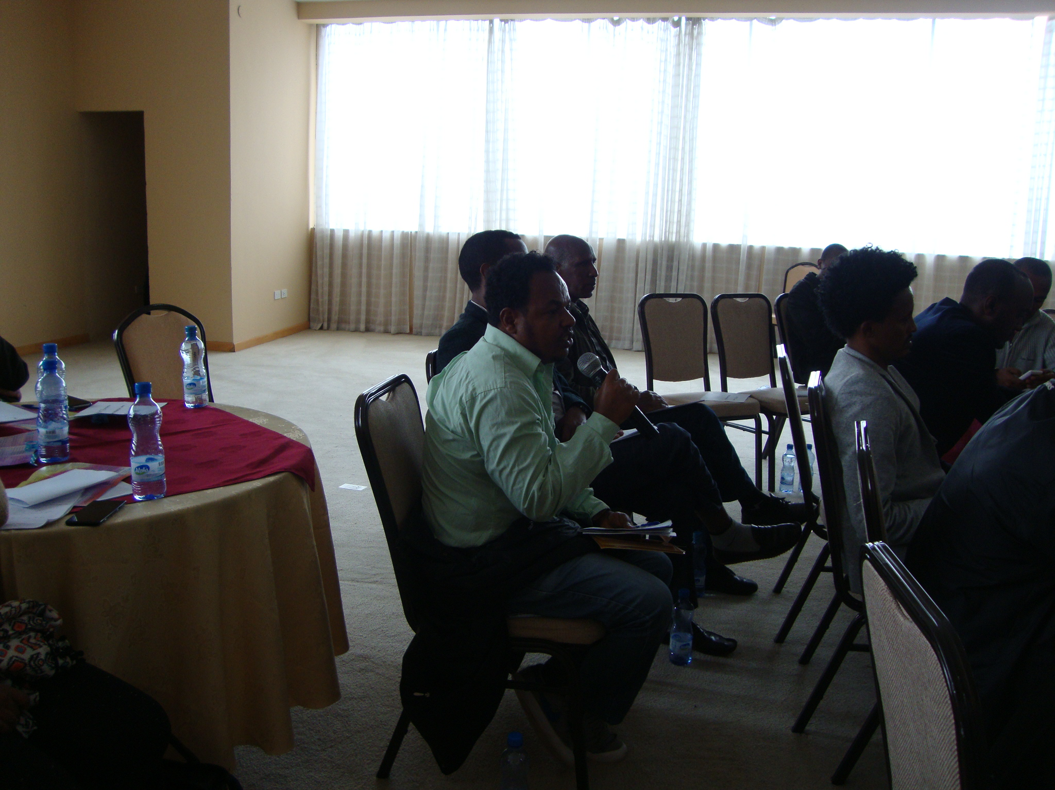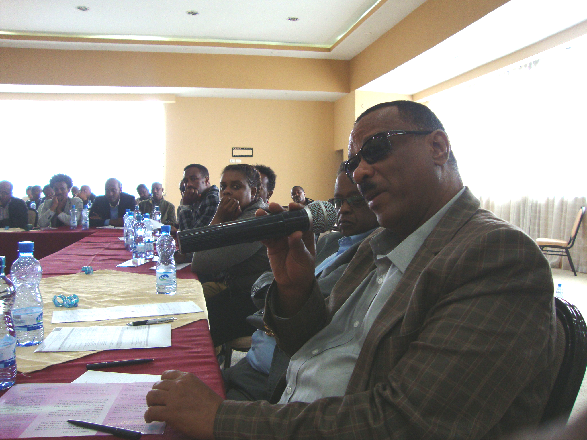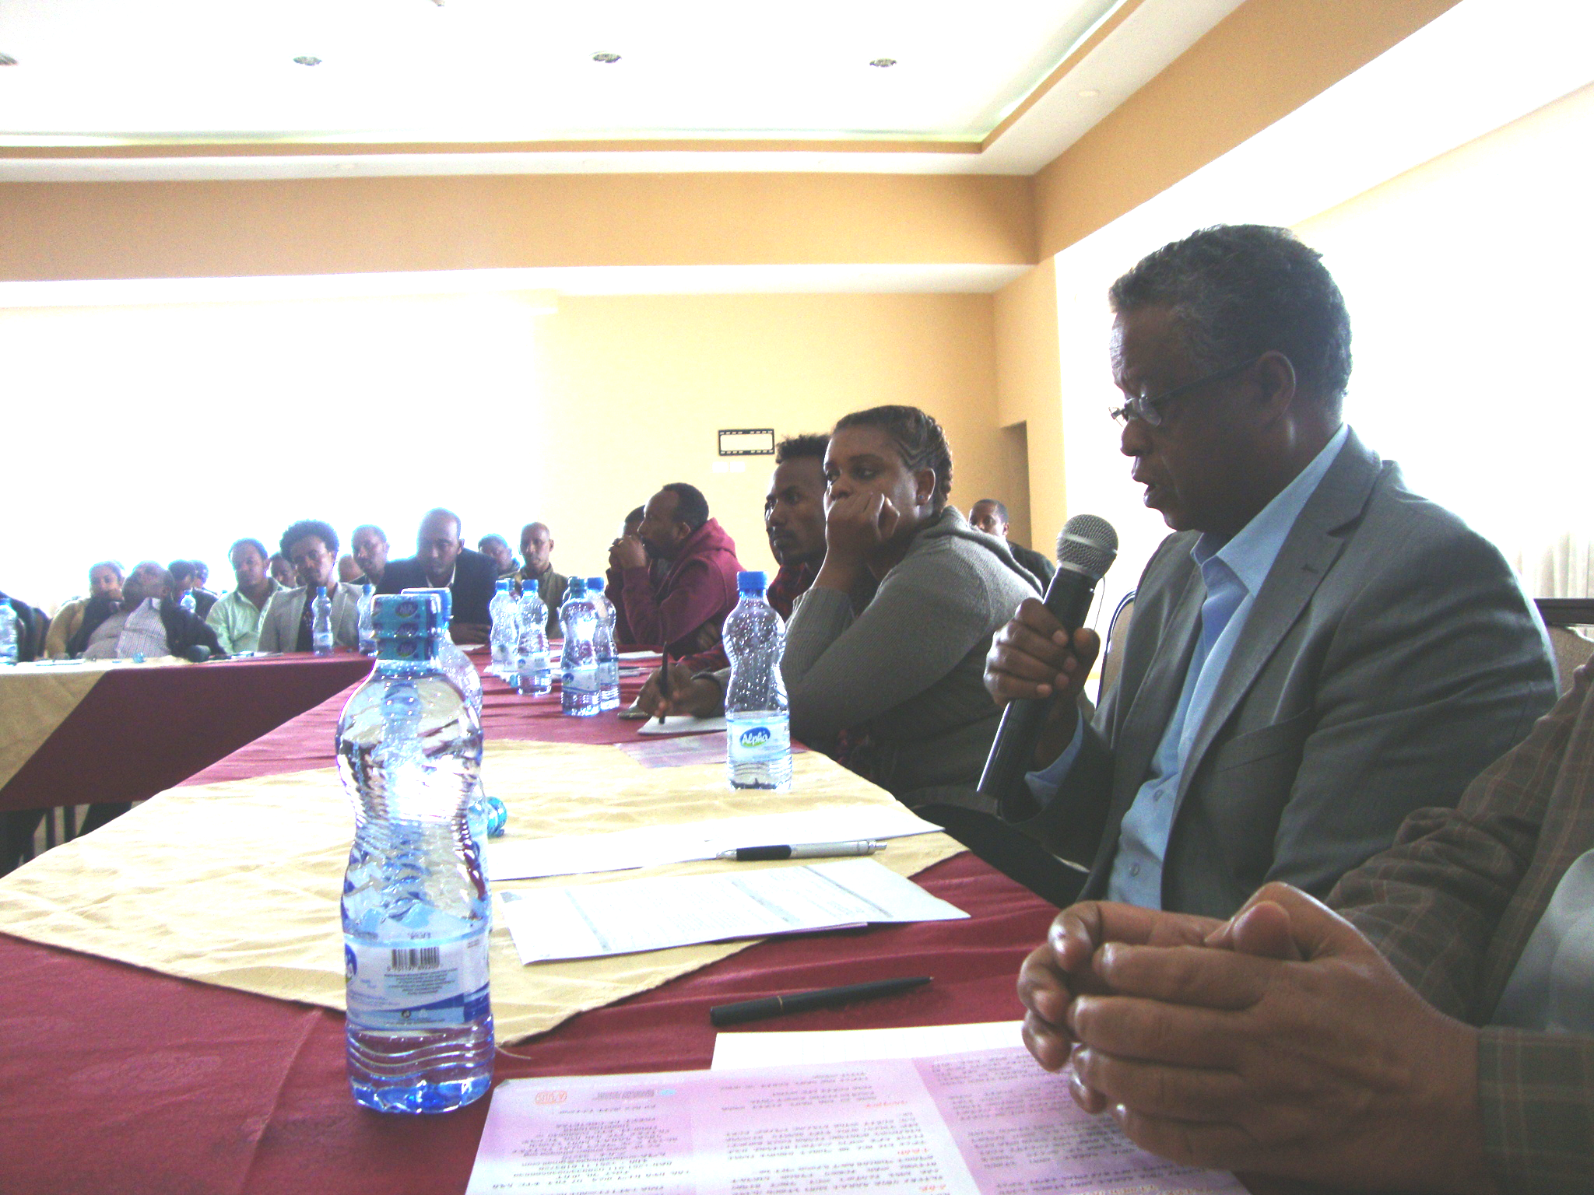
Partial view of participants forwarding questions and suggestions
Reflections by Presenters
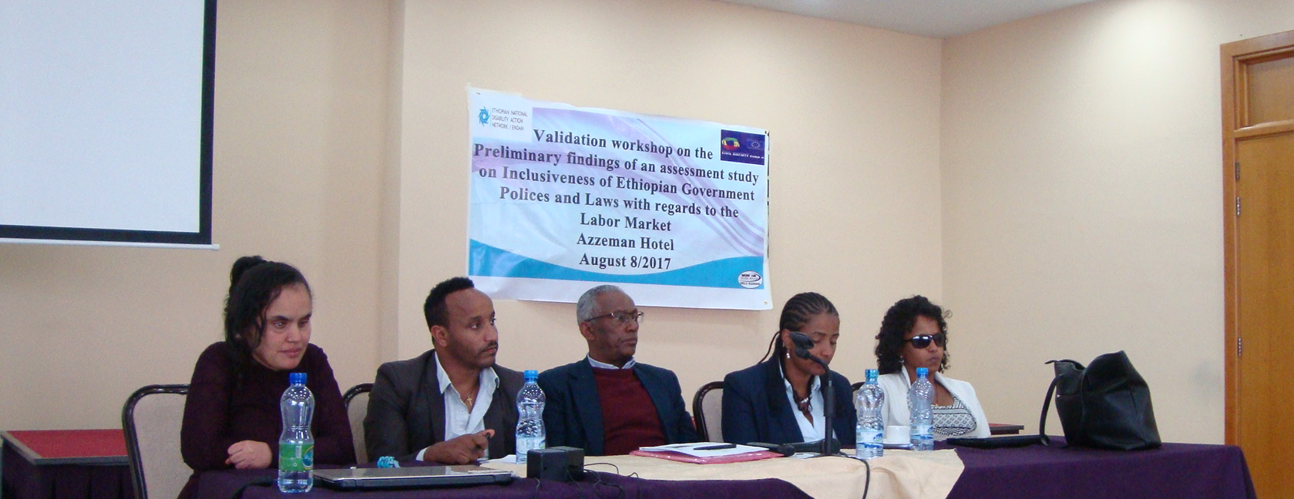
It was noted by Ato Fantahun that the discrepancy between WHO and CSA regarding the data of Ethiopians with disabilities mainly arises because of lack of awareness by the society on the importance of the national census, minimal or no awareness on terminologies used to describe persons with disabilities. In addition, derogatory terminologies that were employed during the census had impact on the people not to respond positively. Moreover, underestimating the capacities and potentials of PWDs and terming them as ‘non functional’ groups of the society had impact on their exclusion from the census.
It is pointed out that preparation has already underway to properly collect the data on disability during the upcoming census. They marked the importance of the data by saying “What is not counted is not accounted”.
The Quota system is also another topic that the presenters reflected on. They said that it is one of the tools that promote access of persons with disabilities to decent work. From the quota system, PWDs living in neighboring countries like Kenya has benefited a lot. However it should be accompanied by enforcement mechanism.
Concerning the question raised in relation to VAT proclamation, Ato Fantahun Melese has explained that the provision could benefit small organizations with few employees. And, according to ECDD, 7 organizations are currently benefiting from the VAT proclamation by hiring 50 or more PWDs in their organizations.
Some of the suggestions/reflection provided by participants includes:
- Labor proclamation 377 is under amendment and sharing the findings of the assessment could be important to enrich the proper amendment.
- There has to be a separate organization/ministry dealing with the issue of disability and DPOs are expected to unite and raise the issue to the concerned government body.
- The enactment of a comprehensive disability act dealing with disability issues is mandatory and experiences from different countries also support this proposal.
- Public interest litigation is an area of less focus in the country , encouraging persons with disabilities to litigate their cases is important to bring change in the employment of persons with disabilities
- Public enterprises are major employers in Ethiopia and the progress made so far in the recruitment of PWDs by government has to assessed and audited
- Awareness issue is issue of good governance, it is right issue and because government is taking about good governance it will be wise and necessary to raise the issue of PWDs as part of it
- It is advisable to conduct compliance and implementation audit by concerned parties working on disability
- Government has enacted disability sensitive laws and polices but they are not goals by themselves, they are a way for creating an inclusive society

Selected priority Action points for better change
- There is a need for stakeholders to assign disability focal persons in their respective organizations and link them with MOLSA
- Quota system need to be introduced in the employment rights of persons with disabilities to expedite the recruitment process of PWDs
- Working on awareness issue is also vital to promote the inclusion of persons with disabilities in the labor market.
- Different approaches should be taken to get the attention of top legislative organs of the government
- The workshop proceeding report should be shared to major stakeholders so that common understanding would be taken among the stakeholders
- The collaborative action should be continued between NOVIB and ENDAN
- The disability based organizations should use the current political will and commitment of government to best benefit of persons with disabilities.

Conclusion of the workshop

Closing and concluding remarks of the workshop is made by W/t Hanna Bekele, the General Manager of ENDAN. She has appreciated all of the participants, presenters, discussants and staffs of the two network organizations for the efforts made in making the workshop effective and fruitful. She has highlighted on the actions to be taken by participating organizations and call upon for their continued engagement and collaboration.

