Proceedings
On
Celebration of the International Women’s Day Event

Organized by: - Ethiopian National Disability Action Network (ENDAN)
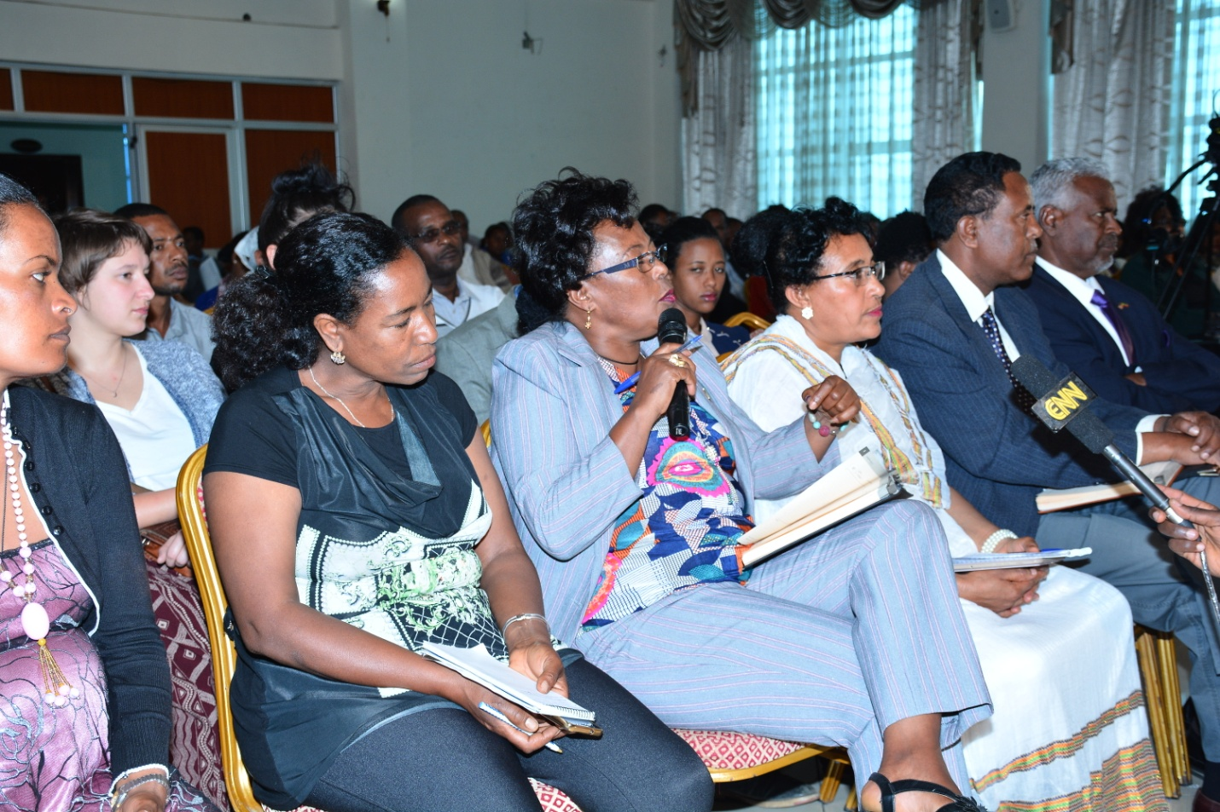
Supported with a Grant and Technical Support of
European Union Civil Society Fund (EU CSF) II and VSO
Venue: - Sarem International Hotel

Addis Ababa
23rd March, 2018

Introduction
According to Wikipedia, International Women's Day (IWD) is celebrated on March 8 every year globally especially after it was adopted in 1975 by the United Nations. Following the struggle, notable changes have been witnessed although still many issues such as the gender parity which is over 200 years away, need to be addressed. (https://www.internationalwomensday.com
Women with disabilities are also still amongst the most disadvantaged and marginalized, and have very few opportunities in life to look forward. Since they have very limited access to participate in economic activities, they are unable to break the vicious circle of dependency, isolation, discrimination, and poverty.
ENDAN therefore organized an awareness raising event in relation to the International Women’s Day with the objective of raising the awareness of the participants including the higher officials, on the status and contribution of women with disabilities in the development of the country and encourage all actors to Press for Change to ensure the proper inclusion of women with disabilities.
The Event was colorful as well as educative. A presentation that ignited discussion on “The Status and Role of Women with Disabilities for the inclusive development at national and international levels” was made by Loret Yetnebersh Nigussie, a pioneer advocate in the disability sector. In addition, outstanding contemporary dance performance by ladies with disabilities and cultural dance performance of youth with hearing impairment including females and an inspiring poems presented by a poet woman with visual impairment were among the activities which evidenced that capabilities are revealed by opportunities.
The event was also inclusive in that disabled and non-disabled males also participated in making the day vibrant.
Theme of the Event
The 2018 internationally agreed theme is Press for Progress with the aim of ensuring gender parity. The ministry of women, children and youth affairs celebrated the day with a slogan of “በተደራጀ የሴቶች ተሳትፎና ንቅናቄ የሴቶችን ሁለንተናዊ ተጠቃሚነት እናረጋግጣለን”. ENDAN though used both the international and national ones; it has modified it to serve its purpose of organizing the event as follows;
“አካል ጉዳተኛ ሴቶችን በልማት ዘርፎች ውስጥ ለማካተት እንትጋ!!” and “Press for Progress to Ensure Meaningful Inclusion of Women with Disabilities in Development!”
Participants of the event
The event was attended by 180 persons among whom 123 were females and the majorities were persons with disabilities. Representatives of different government ministries, democratic institutions, government bureaus and Wereda level offices; representatives of TAU of EU, local and international NGOs, women’s associations, community members with different types of disabilities and family members and journalists were among the participants of the event.
Opening session

W/t Hana Bekele, the General Manager of ENDAN, welcomed the honor parliamentarians and participants. In her speech, she mentioned the efforts ENDAN has made to improve the capacity limitation of the organizations working in the disability sector and to bring about collaborative efforts among disability based organizations intended to improve the situations of persons with disabilities. She also mentioned the role it plays in ensuring the participation of persons with disabilities in the development sector by trying to combat the various challenges persons with disabilities, giving particular attention to women with disabilities.
W/t Hana gave recognition to the efforts the government is making in issuing legislations that promote the rights of persons with disabilities. However, she also noted that execution of the laws is way behind and hence contributed for the prolonged victimization of women with disabilities through the multifaceted versions of discrimination. She gave emphasis that the issue of women with disabilities is the agenda of all GOs and NGOs and should not be left for gender/women based organizations only. She finally thanked EU-CSFII and VSO for the financial and technical support they made to this event.
Presentation on the Role and status of women with disabilities -By Loret Yetnebersh Nigussie: “The Status and Role of Women with Disabilities for an Inclusive Development”
Loret Yetnebersh started her presentation by giving brief introduction about Helen Keller because she won the spirit of Helen Keller Award. In relation to this she noted that Helen Keller is a Deaf Blind woman who fought the life challenges and become visible to the world in an era when there is no awareness about disability in general. She also showed the magnitude of the problem Helen was facing.
Regarding the major topic of presentation, she focused on the prevalence of disability among women, the status of women in leadership; the legislative opportunities women with disabilities have and made her recommendations. The presentation is summarized as follows;
1.1. Prevalence of disability
She showed that females are exposed to disability more than their male counterparts through statistical evidence that the prevalence of disability among women is 19% whereas it is 12% among men. The reason behind this includes violence against women, accessibility of health facilities, their close contact with children and their inclination and preference to use traditional medicines. In relation to violence against women, she mentioned that women and girls with disabilities are even more likely to be exposed for gender based violence.
1.2. Legislative opportunities for women with disabilities
She mentioned legislations promoting the rights of women with disabilities. among the major ones, the UN Convention on the rights of persons with disabilities(UN CRPD) and FDRE Proclamation 568/2008- The right to employment for Persons with Disabilities. the Article 3 of UNCRPD that states equality between Male and Female and Article 6 –that obliged state parties to take all the necessary measures to ensure the full and equal enjoyment by them of all human rights and fundamental freedoms. This article is further explained separately under the General Comment.
1.3-The status of women with disabilities in leadership
The representation Women with disabilities in leadership is also covered by Loret Yetnebersh. She mentioned the UN Convention on the rights of PWDs and bring to light that the representation of women with disabilities in the committee established internationally to review UN Convention on the rights of PWDs is almost very insignificant. Only one woman with disability among 18 member of the committee is available. at national level also the leadership role of women with disabilities as board of directors is almost insignificant. Almost all of the board chairpersons of the National Associations of Persons with Disabilities except Ethiopian National Association of Women with Disabilities are males. For instance, Ethiopian National Association of the Blind (ENAB) where she is a member had never nominated women with disabilities as board chair. But women were given the opportunity to entertain their issues through the women wing but were under control by the chair persons of the associations she termed as “Head”. She added that “Wings cannot fly objectively without the Head/brain!” which is an interesting expression that showed how their activities were controlled and hence had limited scope. In relation to this, she mentioned the historical establishment of the Ethiopian Women with Disabilities National Association (EWDNA) by visionary and pioneer women with disabilities which helped to entertain the issues of women with disabilities separately.
The involvement of women with disabilities is also limited in the ministry of Women, Children and Youth, according to Yetnebersh. She mentioned a case in which the Ministry responded repellently to women with disabilities that the institution is set up for women and not for persons with disabilities, for their appeal related to gender. She showed the magnitude of the challenges women with disabilities are facing and the level of attention they seek, by saying that
“If the Ministry is not working for PWDs then women with disabilities are eligible to setup their own ministry.”
Recommendations
- Promote and encourage women with disabilities to come to leadership. This includes Ministry of Women, Children and Youth, Parliament, in their own associations etc.
- Provide access to education for women with disabilities
- Raise the awareness of the general public and the government executives on the capabilities and rights of women with disabilities including their reproductive rights.
- Improving the legislations with the objective of avoiding the derogatory terminologies used in some of the old legislatives and promoting the employment rights of women with disabilities through provisions on affirmative action to combat the prevailing challenging situations they are still facing.
- Improving the institutional setup of governmental organizations to include/accommodate the issues of women with disabilities.
- Issue of women with disabilities should be accompanied with sufficient budget. They need to be included in UN-Women agenda as well.

Discussion
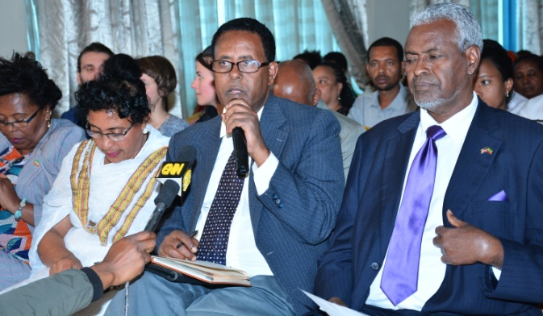
Most of the participants thanked the presenter and organizers and raised the following questions and suggestions;
- A lady, who is writer by profession, mentioned that the issue raised today is burning. Women with disabilities are amongst the most marginalized persons. Men with disabilities are on an equal footing with non-disabled females but the females with disabilities are even less privileged to non-disabled women and even to disabled men. Women with disabilities are included in most organizations for fund raising purpose only. Regarding UN-Women, I am a writer and have got a chance to request for funding to publish my book because I had the information that they sponsored and published a book written by a non-disabled woman. But I feel that they systematically avoided me by saying that they publish only for groups.
- A lady from Shola Women’s Association mentioned that there are several laws promoting the rights of persons with disabilities. However, the execution is way behind.
- A lady with disability said that “I have neighbors who smoke drugs. Although I applied for the concerned Kebele, to no avail. I don’t know where I should put my appeals.”
- The delegates from the House of People’s Representatives- mentioned that the different performances we have seen today simply proved that women with disabilities are capable to do any activity. That is how change can be entertained. Persons with disabilities should believe in themselves first.
- The delegates from the Women and Children Affairs Standing Committee of the House of People’s Representatives supported the prior speaker that showed the multifaceted problem women with disabilities are facing. In order to mitigate the problems she mentioned the need for unified voices in the form of association as important point. In addition, women should be strong to fight back the negative attitudes by males because they even don’t attend tutorial classes due to the same reasons. Affirmative action should not be continuous but should be applied effectively and stressed what Loret Yetnebersh mentioned to show the importance of women in leadership-“wings cannot fly without the head/brain!”
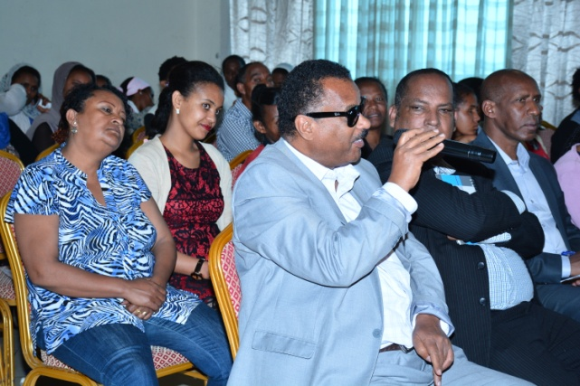
- Representative from NOVIB mentioned that as compared to many developed countries the status of women with disabilities in leadership seems to be good. He showed that in the world, the participation of women in leadership in general is minimal. He supported his view with evidences that showed minimal or no participation of women as presidents of 45 African countries or in presidential history of America, the 1st most developed country. He added that there is no instance showed that leadership will not be granted but obtained through consistent fight. Hence women with disabilities should unite themselves and for the creation of inclusive society. ENDAN and NOVIB through the EU-CSFII . The assessment studies conducted by the partnership of ENDAN and NOVIB have identified that the legislatives including the EFDR Constitution have gaps that hinder inclusive development. Therefore we soon would approach the HPR for serious of policy dialogues.
Reflections made by Loret Yetnebersh
I agree with the last speaker that power /leadership cannot be given as a gift and needs continuous fight from the side of the women. However, our models could not be countries that do not respect the rights of women. We should compare ourselves with Rwanda where 60%of the parliamentarians are women and Kenya and Tanzania where women are represented very well in leadership. This is because of the proportional representation the countries follow in their political system. We could also think of how to promote women in leadership. Discussion cannot by itself bring solution without action points and follow up.
Therefore she suggested the following action points:
- Budget allocation for the issues of women with disabilities :-ENDAN, the organizer of the workshop is advised to prepare a statement of Action that notifies the meaningful inclusion, backed with budget, of women with disabilities, in the Ministry of Women Children and Youth agenda.
- Proposed gender inclusive disability checklist:-The Women and Social Affairs Standing Committee of the Parliament have 18 issues in its checklist used to examine performances of the executives. Among these, one is on issues of disabilities. Appreciating their effort, it is advised to revise the disability checklist with a “gender lens” so as to ensure the inclusion of women with disabilities, who are the most marginalized part of the society.
- Advised the law makers to obey the laws they issue:-The parliament needs to be responsible and abide by the laws it proclaimed. She mentioned that the 1st violator of the building proclamation No/ 624, is the Addis Ababa Council. They need to take corrective measure and ensure that it is respected by others.
- Restore the advocacy mandate of the associations of persons with disabilities:-It is mentioned that The Charities and Societies Proclamation has crippled the advocacy activities. Work for the revision of the Proclamation to enable the advocacy services be rendered by the Associations of Persons with Disabilities to their members.
Performances by persons with disabilities
Contemporary dance performance by Setawit Dance Group was amongst the activities designed to entertain the participants of the event. It was fascinating to see the outstanding dance performances made by ladies with disabilities attaching meaning related to gender based violence to their movements. The dancers are all women with physical disabilities but pointing out their impairment /disability during their artistic presentation was a test by itself.
Insert Picture of Hearing impaired dance group and Setawit
Cultural dance performance of youth with hearing impairment including females was another entertaining show. Persons with hearing impairment made incredible cultural dance performances without listening to the music.
Inspiring poems in English and in Amharic were also presented by a poet woman with visual impairment, w/ro Bekelech Teruneh. Her poems focused on how opportunities reveal capabilities of women with disabilities and that disability is not inability!
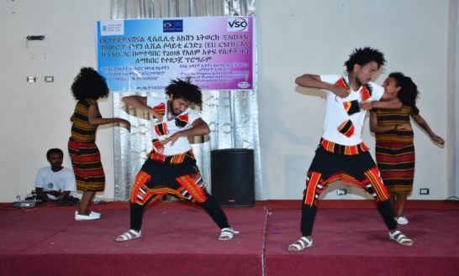
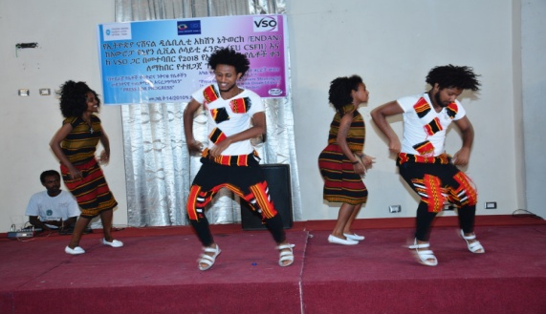
The event was also inclusive in that disabled and non-disabled males also participated in making the day vibrant. A dance group organized by Brothers of Good Work, a member organization of ENDAN gave color to the event. They made magnificent cultural dance performance.

General Evaluation of the Event
As regarded by most of the participants, the event is informative, educative and entertaining. It clearly showed the range of abilities of women with disabilities. The event was attended by 90% of the invited guests and involved different groups starting from the grass root individual women with disabilities to the highest officials of the country. The active participation of the attendants’ and representatives of the Social Affairs and Women’s Affairs Standing Committees of the Parliament was also notable. The parliamentarians have shown their commitment to keenly understand the issues of the most marginalized segment of the society by fully and actively attending the event.
-------------------------------------//----------------------------------

